**PROJECT PROPOSAL**

**Roshan Raj Ramesh**

**209030148**

[**Rrr13@student.ac.uk**](mailto:Rrr13@student.ac.uk)

# Introduction

Battle Royale is the current hottest genre of the eSports industry. PUBG by the PUBG corporation was the first battle royale game made available to the consumers in the year 2017 followed by the epic’s Fortnite later in the same year. Battle royale’s concept is quite simple, yet it had a huge potential to change the esports industry forever. The idea behind this genre is to be the last man standing in a particular landscape. PUBG even got nominated for game of the year 2017 and it had 1.5M, active average users, by the end of the year (According to steam charts).

“In August, Players Unknown Battlegrounds started to routinely claim the top spot on Twitch — something that’s never happened since the unassailable League of Legends rose to power” – (According to polygon.com) [1].

Seeing the success of PUBG and Fortnite, many game developers started to make battle royale games. In 2019, EA’s Apex Legends was released, and it had a great refreshing gunplay experience in a fast-paced environment. Recently blizzard’s COD warzone attracted a huge number of gamers and it does seem to have a great future ahead. But all this started with the game PUBG, which was the pioneer of the battle royale genre. Unfortunately, the PUBG is not where it is supposed to be right now. The game was in the top 5 most streamed game on twitch in 2017 is now in 20th rank in twitch.

# Battle Royale Genre

As mentioned earlier, the concept of the genre is very simple. It is an online multiplayer game, and the winner is the last man standing by killing other players, players can make use of the resources available on the map. Game developers came up with this as a base idea and developed their version of games which has its unique gameplay.

* PUBG [Fig. 1]: Realistic gunfight
* Fortnite [Fig. 2]: Ability to construct buildings that can give an advantage to the player.
* Apex Legends [Fig. 3]: Variety in Legends selection. Each Legend has its advantage and disadvantage. Fast-paced gaming environment.

As many game developers are showing interest in this genre of games, the game needs to be very competitive and satisfying to play or gamers might want to switch to other titles as they offer better gameplay satisfaction. Without players to play the game, the game will eventually die or let bots to play as creating a match would not be possible without the players which what happening right now to PUBG [2]. As mentioned in the introduction, PUBG is losing its player count day by day because of two reasons:

1. Technical issues with the game
2. Problem with the gameplay [which we are focusing on in this study]

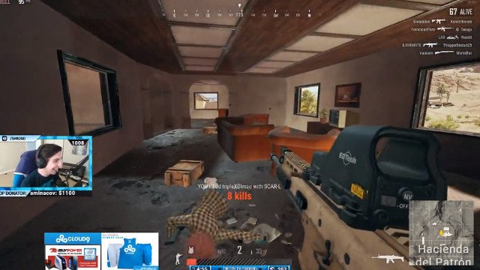

*[Fig.1: PUBG]*

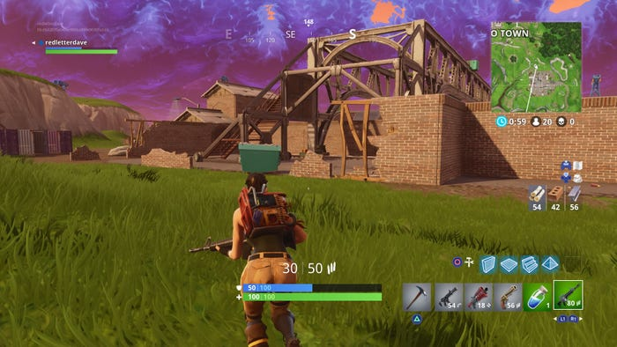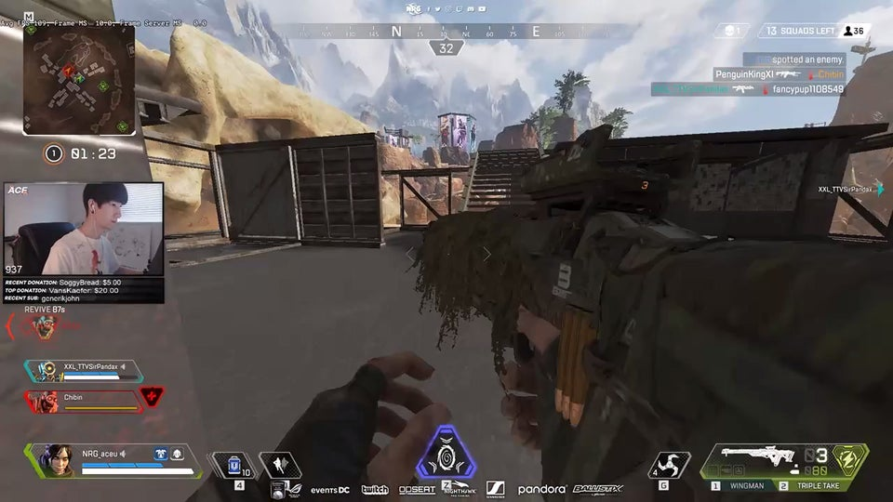

*[Fig.2: Fortnite] [Fig.3: Apex legends]*

# Understanding the E-Sports industry

The money flow of the esports industry is explained below in Fig. 4. Money is exchanged in turn with some asset or knowledge transfer. Fans get their game copy from the game developers, get goodies from the team franchise, video service from the distributors etc. Advertisers get opportunities to advertise their product in a tournament or even in a game. Each block has its purpose, investment and its benefit. Each block is responsible for the E-Sports industry to run successfully. This study mainly focusses on the gamers (fans of E-Sports) and the game developers.

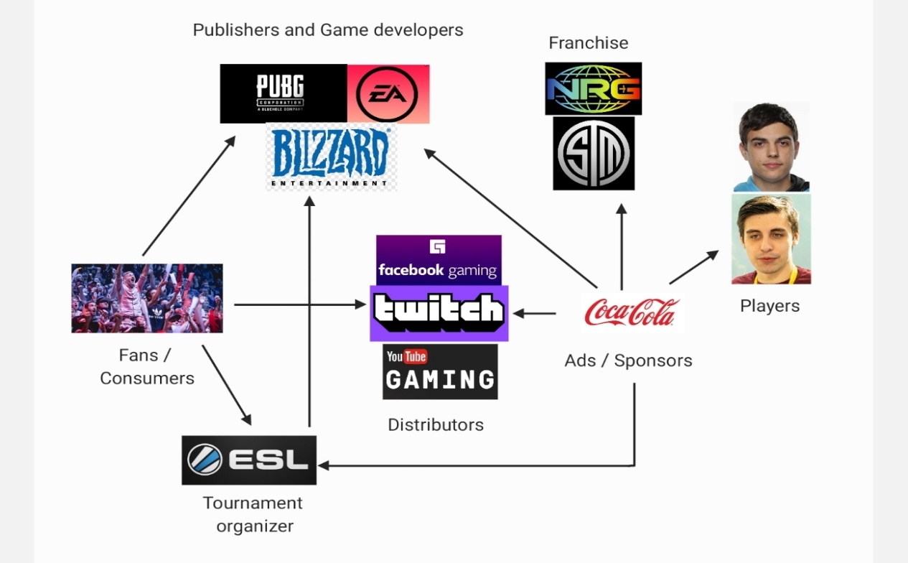

[Fig.4: Simple Money flow structure in the E-Sports Industry]

# The objective of the study

The objective is to make the gameplay experience more fun and satisfying. Also making the Battle Royale genre games more open to welcome interested newbies. Solutions are listed below:

Analysing the reason behind the fall of PUBG with its gameplay datasets, suggesting a solution to the game developers that gamers really want. This can be done by comparing PUBG’s gameplay datasets with currently more famous titles like Fortnite and Apex Legends.

Making an introductory guide for newbies entering PUBG, which makes the game more welcoming and provides satisfaction while playing the game. This will help to lower the skill gap between the newbies and daily gamers.

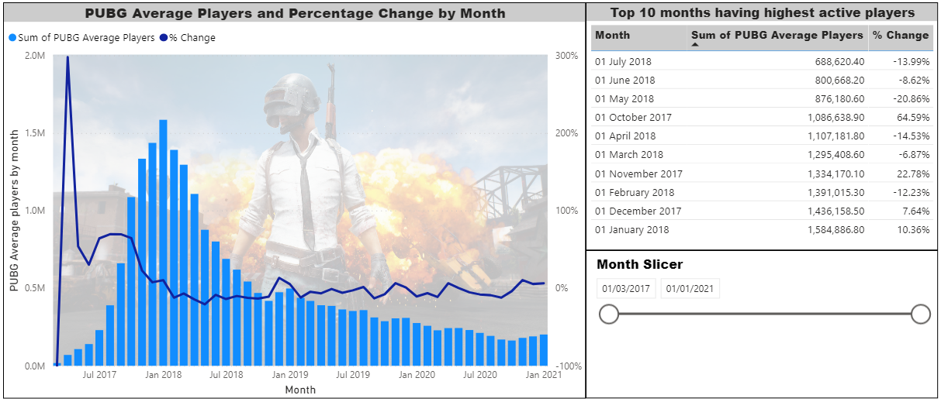

[Visualization 1: Count of Average active players by month]

This interactive dashboard is made in Power BI.

Comparing the above visualization with its season’s release date might give us interesting facts about what went wrong.

# Data requirement and Analysis

PUBG players statistics includes the match type, K/D ratio, Assist/Death ratio, usage of vehicles, walking distance, survival time, placement, squad kills, usage of consumables, damage and much more. Players death location and cause of death is needed to report the blunder mistakes of a beginner player.

For analysis, finding a correlation heat map for all the attributes against one other and finding out the attributes responsible for a player’s gaming performance. Using Principle component analysis to simplify the attributes collected from the correlation heat map making the data volume less without losing much information. Clustering the players using their statistics and segregating professional gamers, casual gamers and newbies and studying their mistakes is crucial information to add in the introductory guide. Also, analysis of weapon versatility should be done across all match type (solo, duos, squad).

Comparing the results obtained from the PUBG’s player statistics with the results obtained from Apex Legends may give some interesting results to share and could also reveal why PUBG losing its player count. An important metric to consider while comparing the games is that the damage done by a person divided by the survival time of the player. We can’t make everyone win in a battle royale match, but what we can do is to provide an opportunity to have a good gunfight which will make the game more fun and will attract many new gamers.

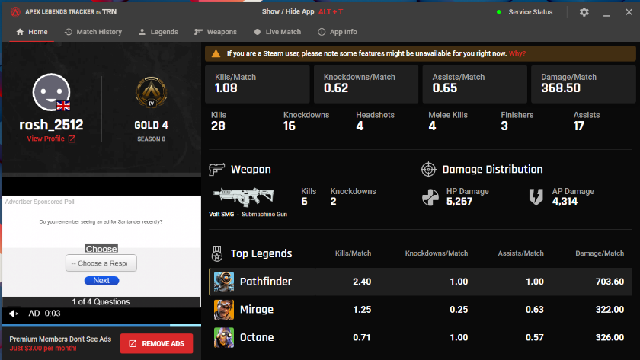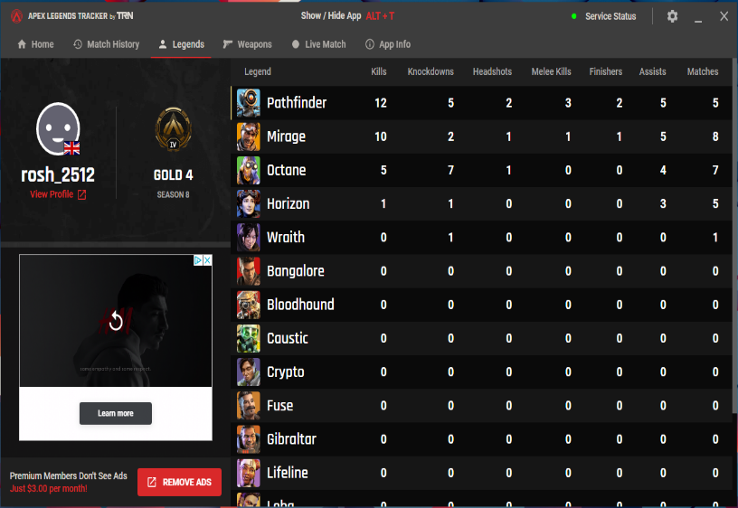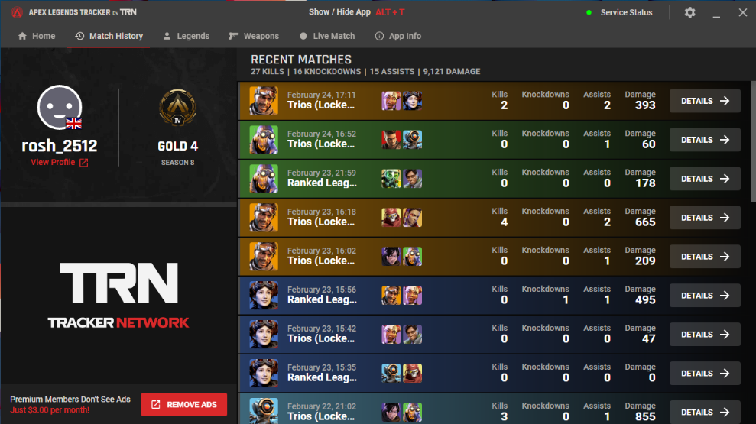 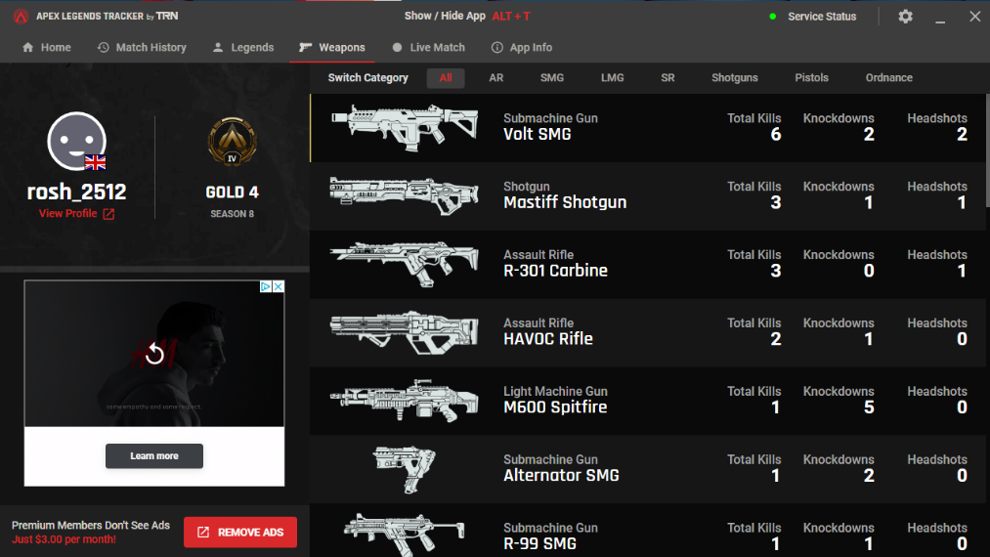

[Fig. 5 Gameplay statistics for my profile in Apex Legends]

Apex Legends Tracker by TRN is used to extract real-time gameplay statistics from my Apex Legends games. Computer vision can be used to extract the data from this dashboard to a CSV file. After extracting it to a CSV file, it should be preprocessed and then can be used for data analysis.

# Summary

In this report, a brief explanation about the Battle Royale genre games was presented and about the money flow in the E-Sports industry. Analysis suggestion was given for making this genre more fun and satisfying, which in turn will bring new gamers to the industry which will facilitate more money flow in the E-Sports industry. Also, trying to find out why PUBG continues to lose its player count by comparing its gameplay statistics with other Battle Royale games.

# Reference

[1] <https://www.polygon.com/2017/9/11/16279064/pubg-is-becoming-an-esport-whether-its-ready-or-not>

[2] <https://www.techradar.com/uk/news/pubg-is-dying-how-bots-threaten-to-destroy-playerunknowns-battlegrounds>

[3] <https://twitchtracker.com/games/493057>

[4] <https://steamcharts.com/app/578080>

[5] <https://tracker.gg/apex>